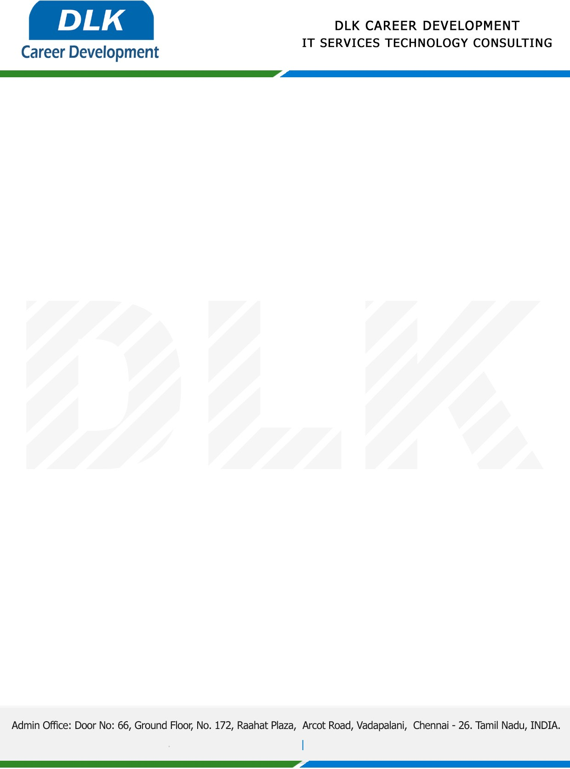

**Date: 13/March /2023**

**SUB: PROJECT COMPLETION CERTIFICATE**

This is to certify that **MR** **SIVA SAKTHI A (REG NO:214012101197) MCA-** **Computer Application** second year student **Dr. M.G.R. Educational and Research Institute University, Chennai** has Successfully Completed the Project Work under the domain of “**JAVA”** in our organization during the Period **(December 2022** to **February 2023).**

**Topic:** Deep neural network-based severity prediction of bug reports

We appreciate your interest in **DLK CAREER DEVELOPMENT**

**“Best Wishes for Your Future Endeavors “**

